Presentation U! Virtual Tutoring
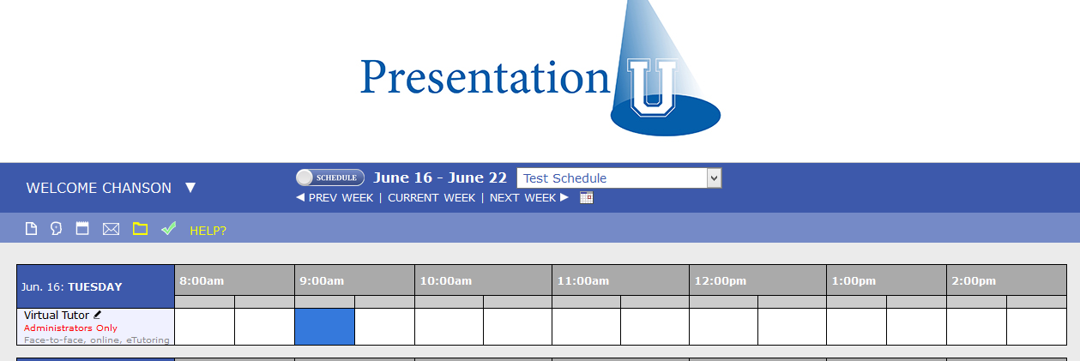
Students may request a virtual tutoring session through WConline by scheduling an appointment with the “Virtual Tutor.” These appointments will appear purple on the schedule.

- Open WC Online. Double click on the appointment to open it. Use your mouse to copy the student’s email address, under his/her hame.
- Write the student’s name and email on your Daily Tutor Log Sheet and check the box for a “Virtual” appointment. Then close WC Online.
Launching the Zoom Client
Presentation U! utilizes “Zoom” web conferencing software to facilitate our online tutoring sessions. The Zoom plug-in has already been installed on laptops labeled “Virtual Laptop”

- Open the Zoom shortcut (located on the desktop).
  - You may also launch Zoom from the
Start menu.

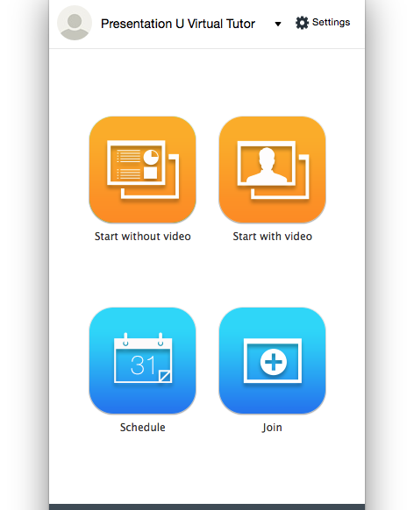
- Fifteen minutes before the Virtual Tutoring Session is scheduled to begin, click “Start with video”

- You may be prompted to join the meeting via computer audio or via phone. Unless you are experiencing hardware issues with your microphone or an extremely slow network connection, you should click “Join Audio” under the “Join by Computer” tab.
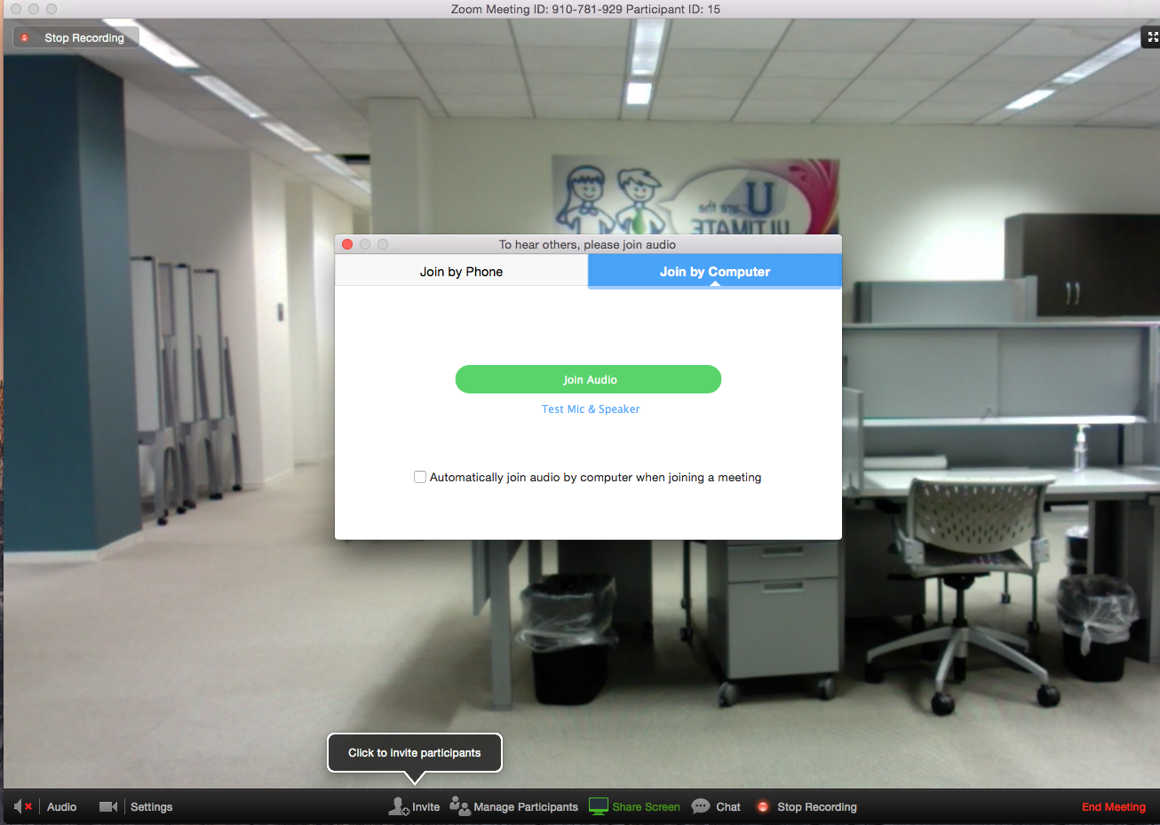

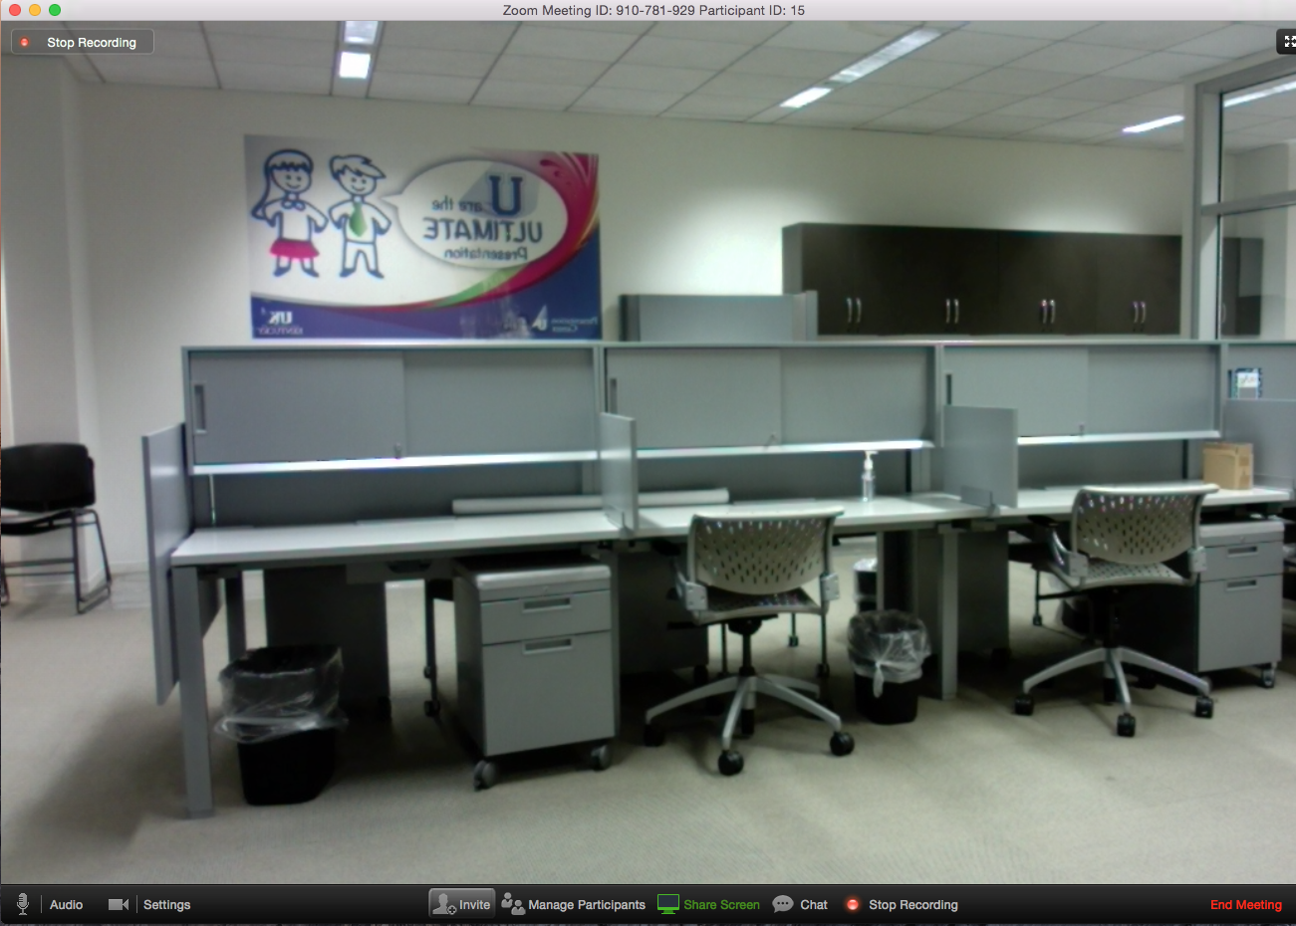
- To invite the student to the video conference, you must click “Invite” at the bottom of the screen, and then Gmail

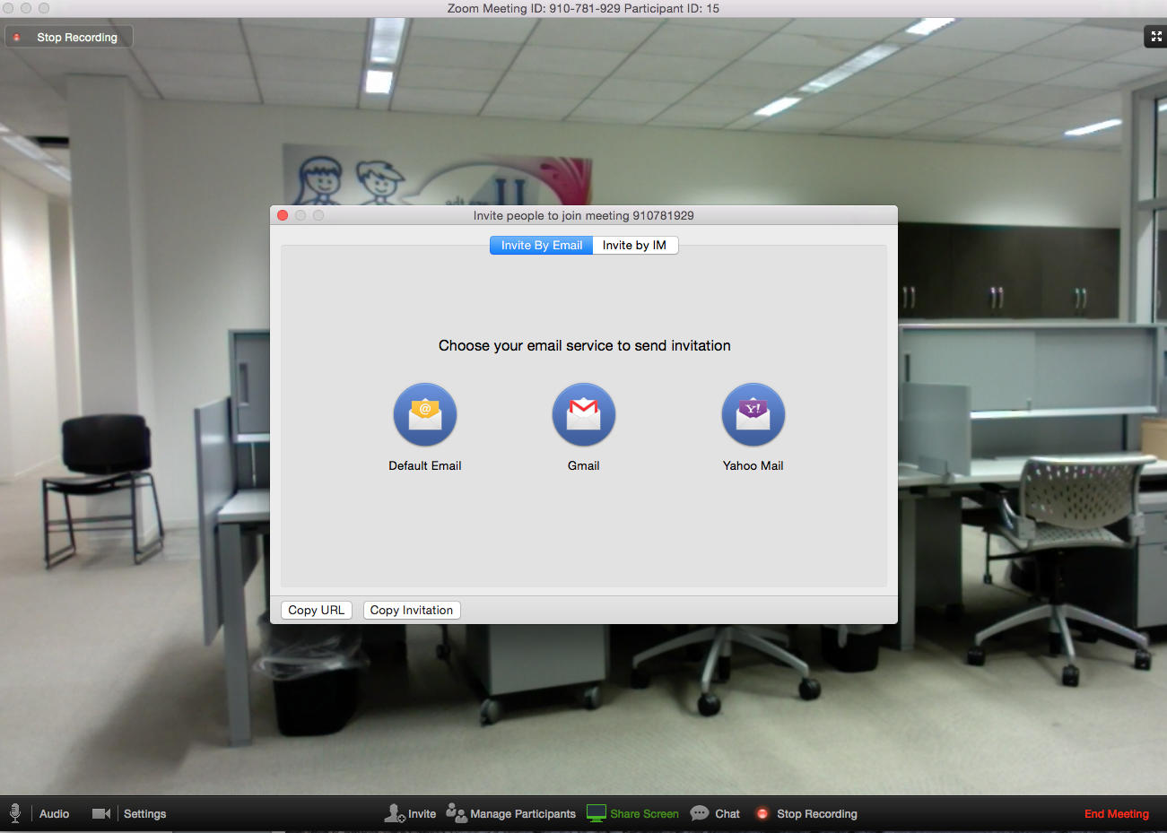

- This will trigger a default email. Paste the student’s email into the address line.
- Replace the subject line with: Instructions to join your Presentation U! Virtual Consultation
- Replace Hi There with the following text:
____________________________________________________________________________
Hi (student name),
Your Presentation U! Virtual Consultation scheduled for (Date) at (Time) is starting soon. Please click the link below to join the meeting:
_____________________________________________________________________________

- After the default message from Zoom, add the following text:
______________________________________________________________________________If you have not used our virtual tutoring service before, you may be prompted to install a Zoom plugin to your browser. You must install this plugin in order to join the meeting. If you are using a Mac, you will need to go to System Preferences (on the apple menu) Security and make sure “Anywhere” is selected under “Allow apps downloaded from.” If you have technical problems, contact ____________________________________________

If you have any documents you wish to share with the tutor during your consultation, please have these documents open on your computer before you join the meeting.

Thank you,
(tutor name)

- When the student joins, you may see a box asking if you will allow incoming connections. Click Yes.
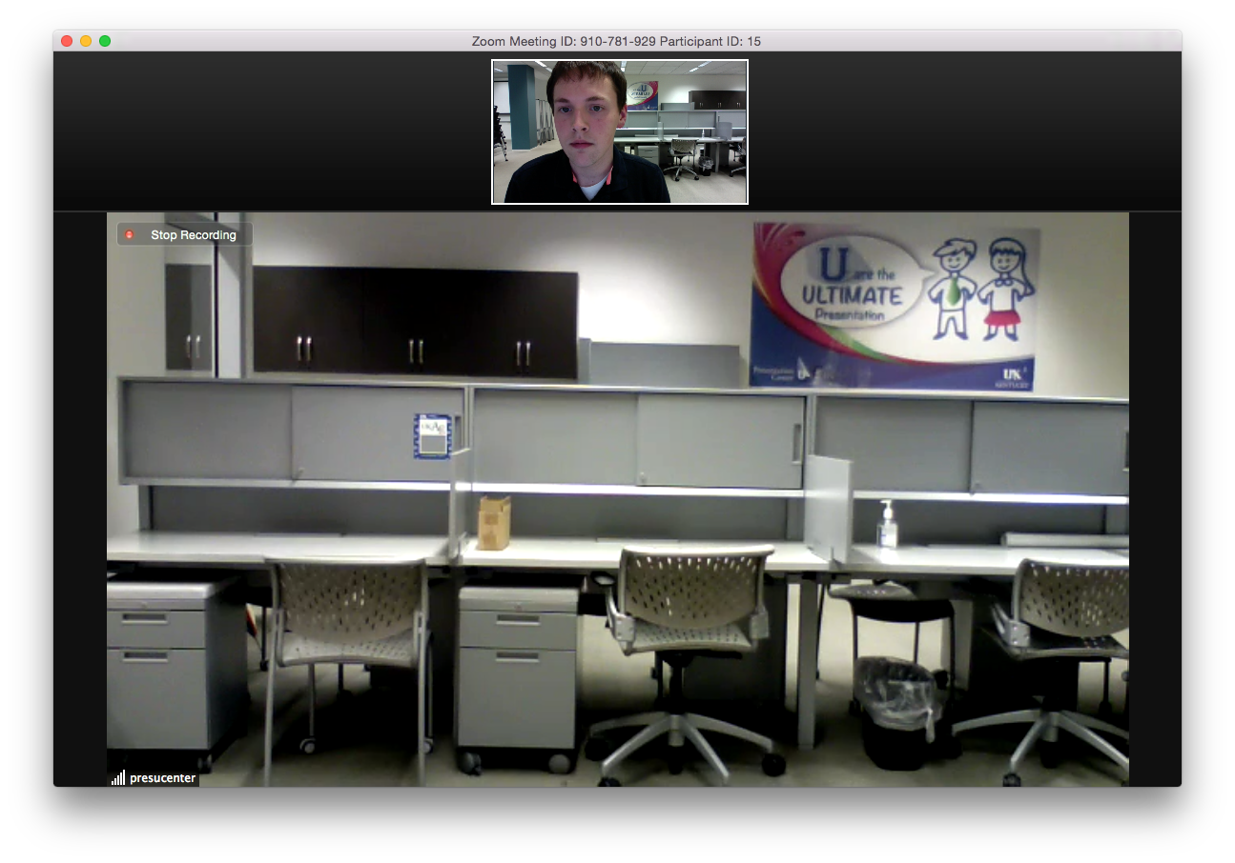
- Once the student has joined the meeting, your window will automatically display his or her camera in the primary frame.

- Click “Start Recording” from the menu at the bottom. We want to record of all the sessions in case a question arises later.
- If you are experiencing difficulties with the audio chat, or if you wish to share a URL with the student, you may open the text chat by clicking “Chat” at the bottom of the conference window. A window will open in the middle of your screen. You can click and drag it to the side, so you can still see the primary window. The chat window should automatically appear for the student after you send a message.
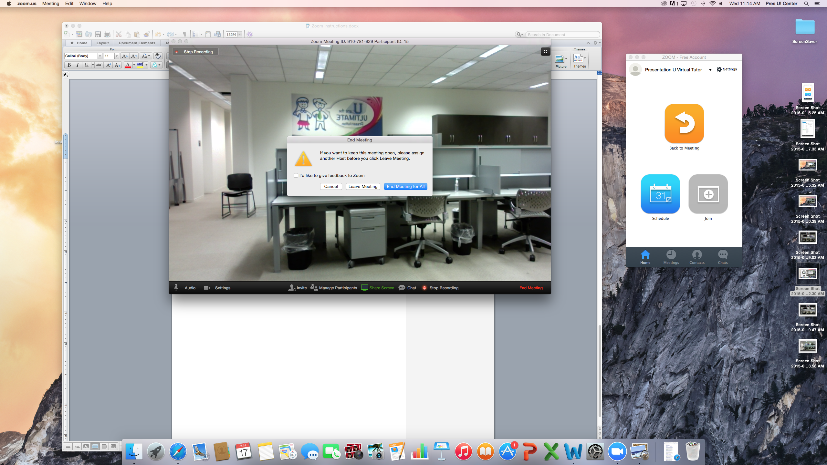

- Greet the student and introduce yourself.
- Ask the student if he/she is a UK student or goes to another school. If the student attends UK, ask and record his/her linkblue ID on the Daily Tutor Log Sheet, so you can check the student into the center later. Otherwise, check “Non-UK student” on the Daily Tutor Log Sheet.

- At this point, you should follow standard face-to-face tutoring protocol (i.e., introduce yourself, assess the student’s needs, discuss how you plan to address the student’s needs, and so forth).
- If the student needs to share a document with you, ask the student to first open the document on his or her computer. The student should then click “Share Screen” at the bottom of the conference window.

- Zoom will then ask the student which window to share. He or she may choose to share the entire screen or only one window. After the student makes this selection, you will be able to jointly control the window with the student for collaborative editing. If Zoom asks the student to give permission to remote control the computer, let the student know he/she should agree.
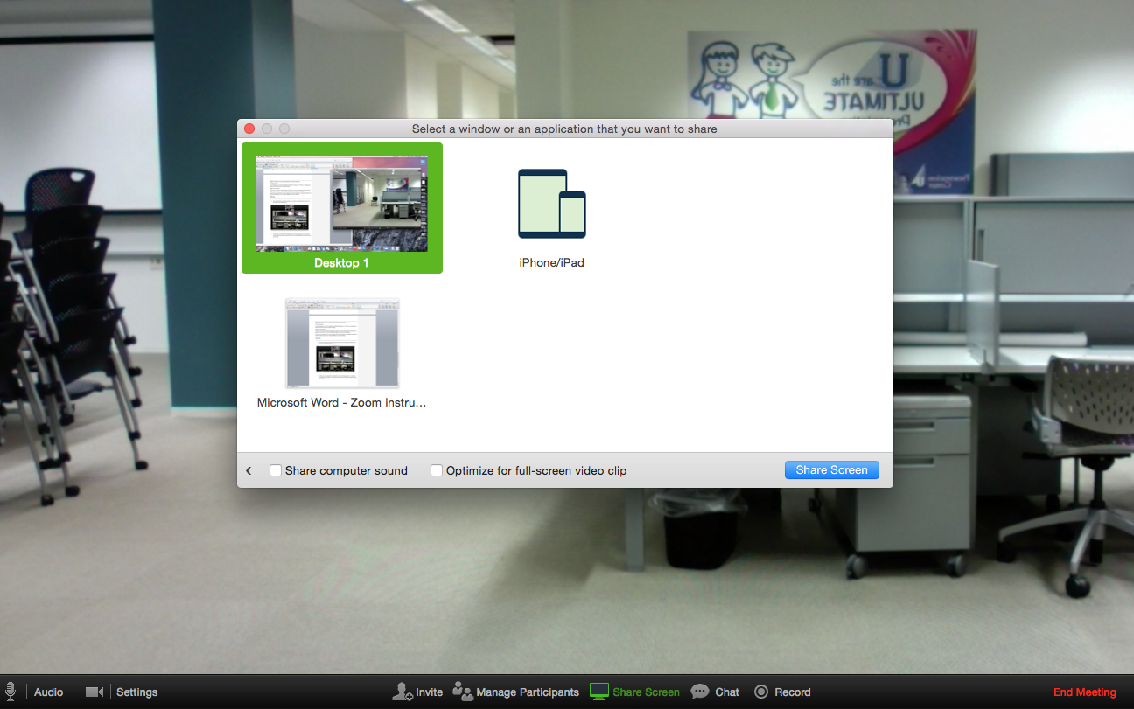

- If needed, it is also possible to share your screen with the student. Follow steps 18 and 19 above from your computer.
- At the end of the session, thank the student for taking advantage of the Presentation U! tutoring services. Inform him/her that you will be sending a follow-up email with notes from the session and a link to a quick 5-minute survey. It would be very helpful if he/she would provide feedback on the session today so we can improve future tutoring sessions. Also remind the student that he/she can sign up for another appointment anytime or drop in for a face-to-face consultation during our regular hours. You may want to send the Presentation U! website link (www.uky.edu/UGE/pres-u-students) by chat.

- At the end of your consultation, click “End Meeting,” and then “End Meeting for All.”

- You’ll see a message the meeting recording is being converted to video. Let the video finish compressing and then close the file menu that appears.
- Log back into WC Online. Create and send a client report form in WC Online as you would for a face-to-face appointment. If the client is a UK student, be sure to include the link for the center survey: https://uky.az1.qualtrics.com/SE/?SID=SV_e2Pv0oMIoVHIxTL. If the client attends another school, they will not complete the survey, but you should still send a follow-up email.
- If the client attends UK, be sure to have the greeter check the client into UK Tagger with the Linkblue ID. Inform the greeter which kind of tutoring the client received (oral preparation, oral delivery, writing, or visual communication help).

